**TASK 5**

To build using the Jenkins modules of the Urbanladder

Code

package testing;

import org.openqa.selenium.By;

import org.openqa.selenium.WebDriver;

import org.openqa.selenium.chrome.ChromeDriver;

import org.testng.Assert;

import org.testng.annotations.BeforeTest;

import org.testng.annotations.Test;

public class UrbanLadderTesting {

WebDriver d;

@BeforeTest

public void launchBrowser() throws InterruptedException {

System.setProperty("webdriver.chrome.driver","C:\\Users\\ustjavasdetb409\\Documents\\chromedriverr\\chromedriver.exe");

d=new ChromeDriver();

d.navigate().to("https://www.urbanladder.com/");

//d.findElement(By.linkText("Log-in")).click();

d.manage().window().maximize();

Thread.sleep(2000);

}

@Test(priority = 0)

public void login() throws InterruptedException {

d.findElement(By.xpath("/html/body/div[1]/header/div[1]/div/section[3]/ul/li[2]/span")).click();

Thread.sleep(2000);

d.findElement(By.partialLinkText("Log In")).click();

Thread.sleep(10000);

d.findElement(By.xpath("/html/body/div[6]/div/div[1]/div/div[2]/div[3]/form/div/input")).sendKeys( "harimurali007@gmail.com");

d.findElement(By.xpath("/html/body/div[6]/div/div[1]/div/div[2]/div[3]/form/div/div/div/input")). sendKeys("harimurali007");

d.findElement(By.id("ul_site_login")).click();

}

@Test(priority = 1)

public void bed() {

d.findElement(By.xpath("/html/body/div[1]/header/div[2]/div/nav/div/ul/li[3]/span")).click();

String s = d.findElement(By.partialLinkText("Beds")).getText();

/*System.out.println(s);

Assert.assertEquals(s,"Beds");*/

}

@Test(priority = 2)

public void mattresses() {

d.findElement(By.xpath("/html/body/div[1]/header/div[2]/div/nav/div/ul/li[3]/span")).click();

String s = d.findElement(By.partialLinkText("Mattresses")).getText();

/*System.out.println(s);

Assert.assertEquals(s,"Mattresses");*/

}

@Test(priority = 3)

public void storage() {

d.findElement(By.xpath("/html/body/div[1]/header/div[2]/div/nav/div/ul/li[3]/span")).click();

String s = d.findElement(By.partialLinkText("Storage & Accessories")).getText();

System.out.println(s);

Assert.assertEquals(s,"Storage & Accessories");

}

@Test(priority = 4)

public void kids() {

d.findElement(By.xpath("/html/body/div[1]/header/div[2]/div/nav/div/ul/li[3]/span")).click();

String s = d.findElement(By.partialLinkText("Kids Bedroom")).getText();

System.out.println(s);

Assert.assertEquals(s,"Kids Bedroom");

}

/*@Test(priority = 5)

public void Allmatt() throws InterruptedException {

d.findElement(By.xpath("/html/body/div[1]/header/div[2]/div/nav/div/ul/li[3]/span")).click();

d.findElement(By.xpath("/html/body/div[1]/header/div[2]/div/nav/div/ul/li[3]/div/div/ul/li[2]/div/a")).click();

//Assert.assertEquals("Beds",s);

//System.out.println(s);

}*/

/*@Test(priority = 6)

public void Storageaccess() throws InterruptedException {

d.findElement(By.xpath("/html/body/div[1]/header/div[2]/div/nav/div/ul/li[3]/span")).click();

d.findElement(By.partialLinkText("Storage & Accessories")).click();

//Assert.assertEquals("Beds",s);

//System.out.println(s);

}*/

@Test(priority = 5)

public void customer() throws InterruptedException

{

d.findElement(By.xpath("/html/body/div[1]/header/div[2]/div/nav/div/ul/li[3]/span")).click();

d.findElement(By.partialLinkText("Double Beds")).click();

String s = d.findElement(By.xpath("/html/body/div[2]/div[4]/div[4]/div[1]")).getText();

Assert.assertEquals("Customer Stories", s);

System.out.println(s);

}

@Test(priority = 6)

public void browsepopular() {

String s = d.findElement(By.xpath("/html/body/div[2]/div[4]/div[5]/div[1]")).getText();

Assert.assertEquals("Browse Popular Categories", s);

System.out.println(s);

}

@Test(priority = 7)

public void doublebeds() throws InterruptedException {

d.findElement(By.xpath("/html/body/div[2]/div[2]/div[3]/div[2]/div[1]/div/form/div[1]/div/div/ul/li[1]/div[1]")).click();

d.findElement(By.xpath("/html/body/div[2]/div[2]/div[3]/div[2]/div[1]/div/form/div[1]/div/div/ul/li[1]/div[2]/div/div/ul/li[2]/div[1]/label/input")).click();

/*JavascriptExecutor js = (JavascriptExecutor) d;

js.executeScript("window.scrollBy(0,0)");*/

//d.findElement(By.xpath("/html/body/div[2]/div[2]/div[3]/div[2]/div[1]/div/form/div[1]/div/div/ul/li[3]")).click();

//Thread.sleep(1000);

//d.findElement(By.xpath("/html/body/div[2]/div[2]/div[3]/div[2]/div[1]/div/form/div[1]/div/div/ul/li[3]/div[2]/div/div/div[1]/ul/li[1]/input")).click();

//d.navigate().to("https://www.urbanladder.com/");

//Thread.sleep(1000);

//System.out.println(s);

//Assert.assertEquals(s,"Double Beds");

}

/*@Test(priority = 8)

public void size() {

d.findElement(By.xpath("/html/body/div[1]/div[1]/div[3]/div[2]/div[1]/div/form/div[1]/div/div/ul/li[5]/div[1]")).click();

d.findElement(By.xpath("/html/body/div[1]/div[1]/div[3]/div[2]/div[1]/div/form/div[1]/div/div/ul/li[5]/div[2]/div/div/div/ul/li[1]/input")).click();

}*/

}

**Pom File:**

<project xmlns="http://maven.apache.org/POM/4.0.0" xmlns:xsi="http://www.w3.org/2001/XMLSchema-instance" xsi:schemaLocation="http://maven.apache.org/POM/4.0.0 https://maven.apache.org/xsd/maven-4.0.0.xsd">

<modelVersion>4.0.0</modelVersion>

<groupId>Urbanladder</groupId>

<artifactId>Urbanladder</artifactId>

<version>0.0.1-SNAPSHOT</version>

<packaging>jar</packaging>

<dependencies>

<!-- https://mvnrepository.com/artifact/org.seleniumhq.selenium/selenium-java -->

<dependency>

<groupId>org.seleniumhq.selenium</groupId>

<artifactId>selenium-java</artifactId>

<version>3.141.59</version>

</dependency>

<!-- https://mvnrepository.com/artifact/org.testng/testng -->

<dependency>

<groupId>org.seleniumhq.selenium</groupId>

<artifactId>selenium-chrome-driver</artifactId>

<version>3.4.0</version>

</dependency>

<dependency>

<groupId>org.testng</groupId>

<artifactId>testng</artifactId>

<version>7.1.0</version>

<scope>test</scope>

</dependency>

</dependencies>

<build>

<plugins>

<plugin>

<groupId>org.apache.maven.plugins</groupId>

<artifactId>maven-compiler-plugin</artifactId>

<configuration>

<source>1.8</source>

<target>1.8</target>

</configuration>

</plugin>

<plugin>

<groupId>org.apache.maven.plugins</groupId>

<artifactId>maven-surefire-plugin</artifactId>

<version>3.0.0-M5</version>

<configuration>

<suiteXmlFiles>

<suiteXmlFile>testng.xml</suiteXmlFile>

</suiteXmlFiles>

</configuration>

</plugin>

</plugins>

</build>

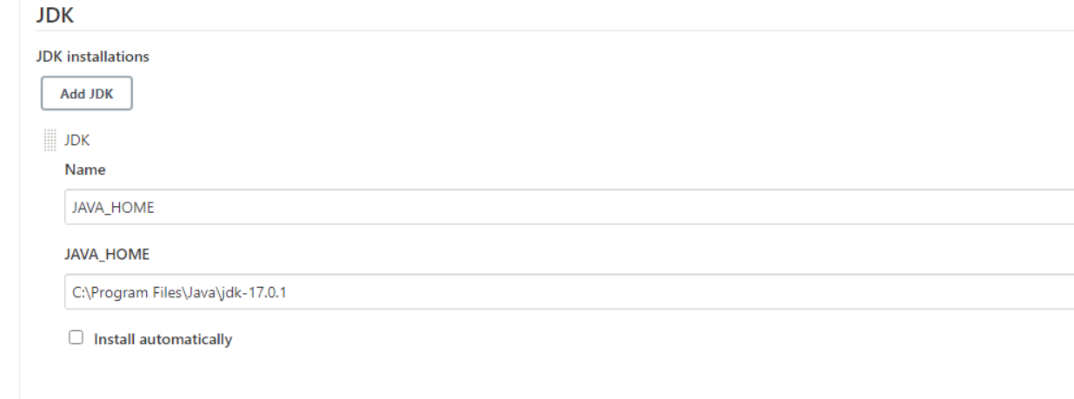</project>

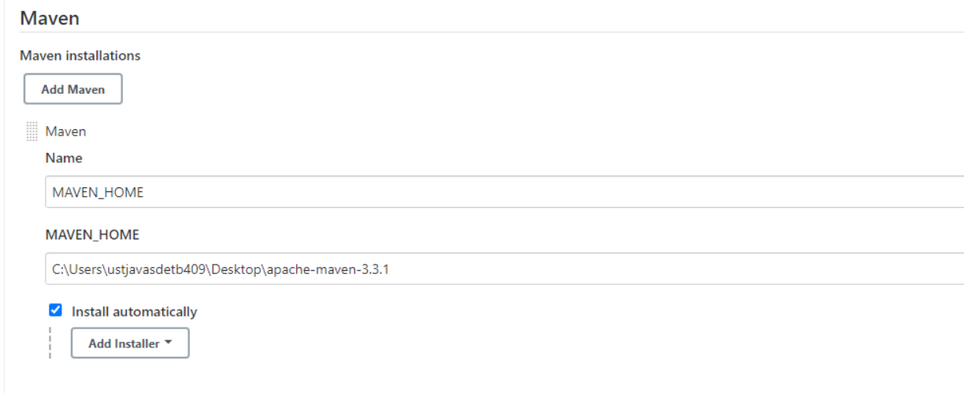

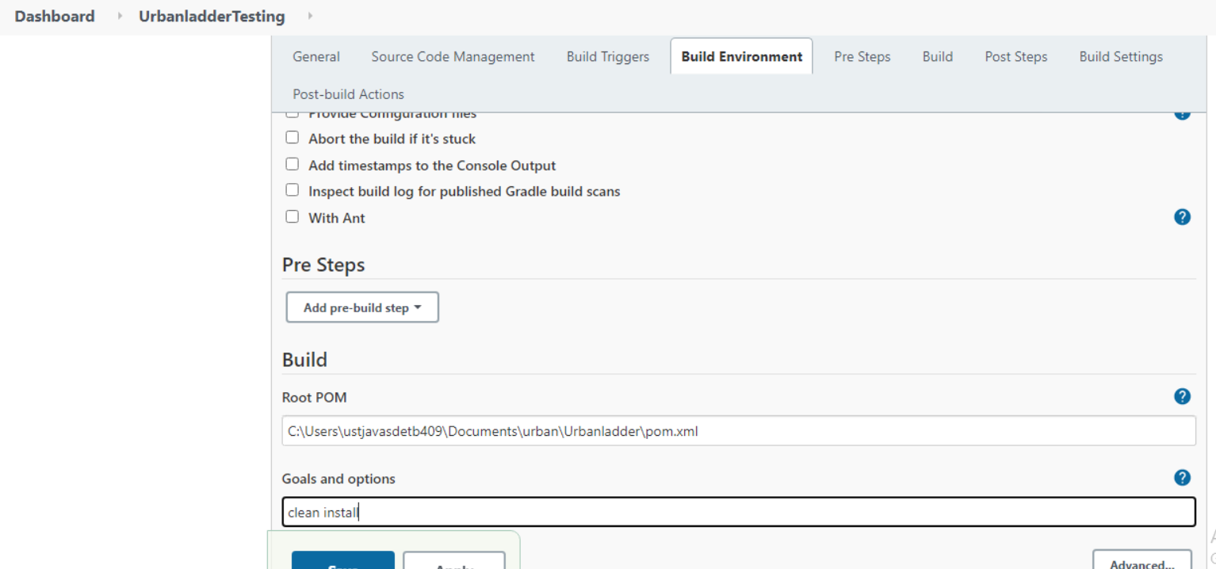

**RESULTS**

